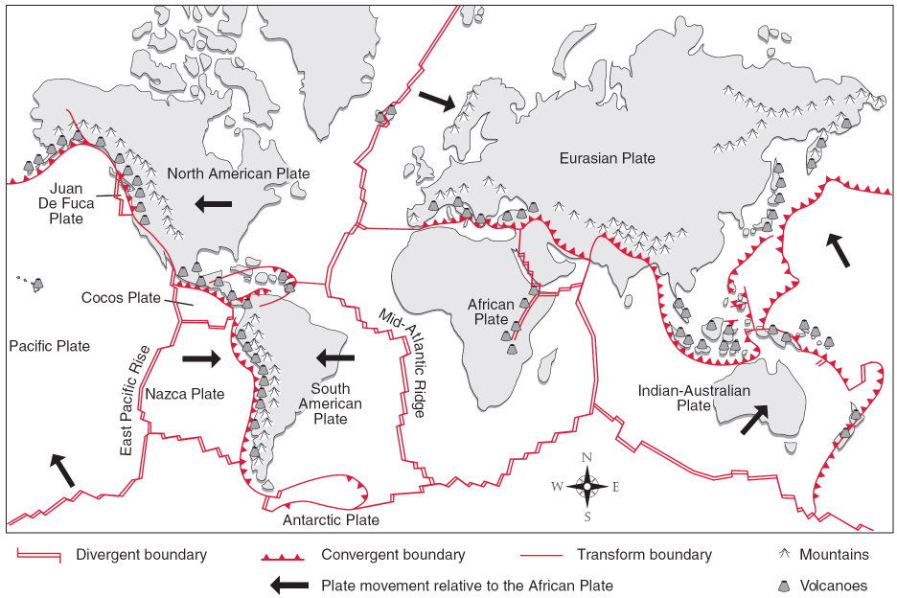
Plate Boundaries

I. Consider the Pacific Ocean area in the tectonic map above. Identify a pair of named plates that are separated by:
a diverging boundary · _____________________ and _____________________.
b a converging boundary _____________________ and _____________________.
2 Consider the Pacific Ocean area in the tectonic map. Identify a pair of named plates that are associated with:
a mid ocean ridge _____________________ and _____________________.
b a subduction zone _____________________ and _____________________.
3 Consider the Indian Ocean area in the tectonic map. Identify a pair of named plates that are associated with an ocean trench.
_____________________ and _____________________.
4 Consider the left-hand side of the tectonic map. Identify a pair of named plates that are associated with a fold mountain belt.
_____________________ and _____________________.
5* Subduction zones and fold mountain belts often occur close to each other. Explain why.
______________________________________________________________________________________________________________________________________________________________________________________________

